Shell Script Assignment
Mandatory:
- Create a script named “myscript” in current directory to do the following.
- display “hello user”
- list files in current directory
- name of logged in user
- date
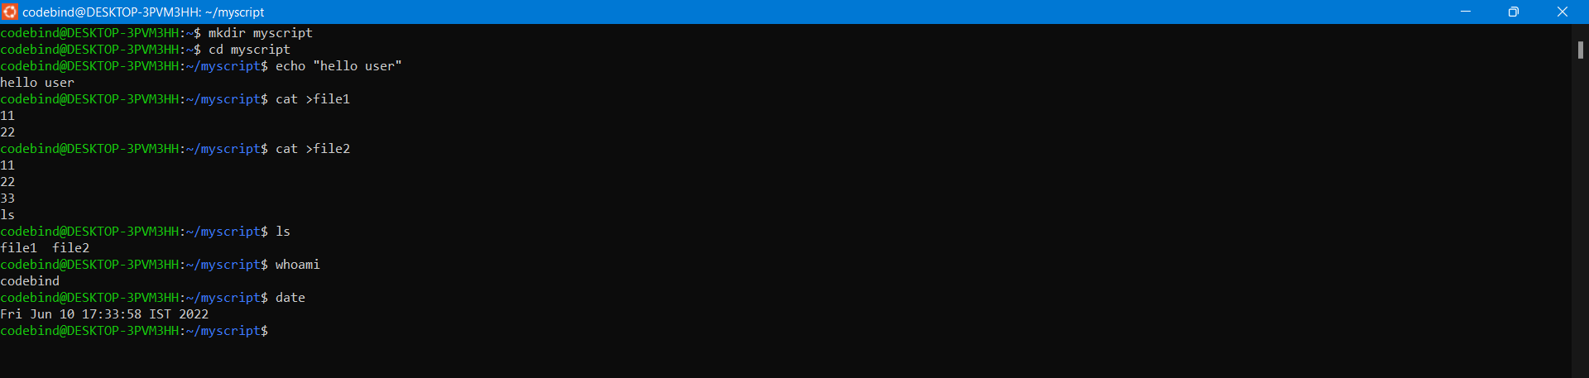
- Add execute permission and Run the script from
- current directory
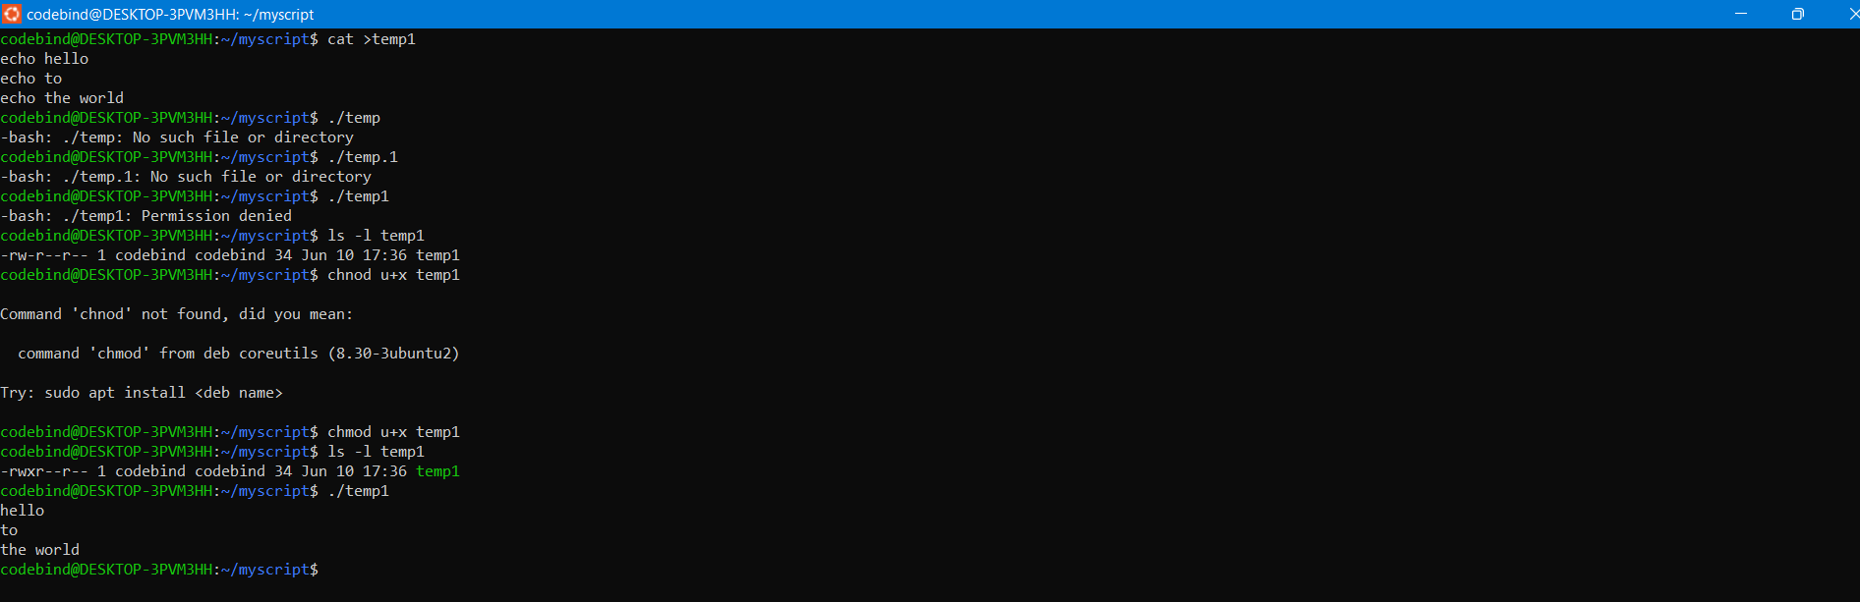
- Create a subdirectory named “test”
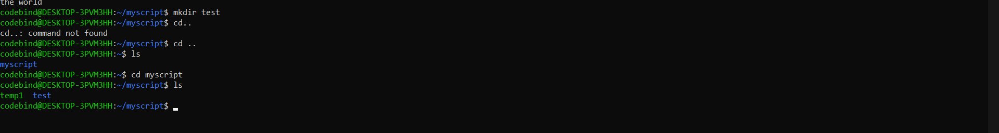
- Change to “test” directory. Run the script “myscript” [Hint: You will have to update PATH to include the directory containg script to run script from any location].
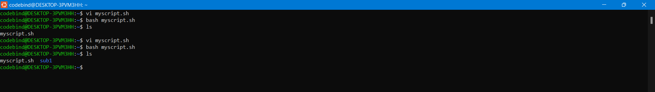
Optional Assignments:
- Considering command line arguments are accessible using $<position> i.e
$0- for first argument
$1- for second argument…

write a shell script to concatenate all command line arguments using ‘_’ and display it as a single string.

Refer example below
$>./myscript.sh ABC DEF
Output:
ABC_DEF
[Refer http://linuxcommand.org/lc3_wss0120.php]

